SS-MOM (2027)
1st International Conference on
Smart and Sustainable Manufacturing, Operations, and Materials
(SS-MOM)
February 04-05, 2027
Organised by
Department of Mechanical Engineering
Mnaipal University Jaipur, India
Co- organisers (proposed)
BITS-Pilani, Dubai Campus, UAE
NIT, Agartala, India
MNIT, Jaipur
Venue:
Manipal University Jaipur,
Dehmi Kalan, Off Jaipur-Ajmer Expressway, Jaipur, Rajasthan 303007, India
About the Manipal University Jaipur
The Manipal Education and Medical Group is an established leader in the field of education, research and healthcare. In a span of over seven decades, it has transformed the lives of more than 3,00,000 students from over 59 countries. The group includes five Universities - Manipal Academy of Higher Education (MAHE, Karnataka), Sikkim Manipal University (Sikkim), American University of Antigua (Caribbean Islands), Manipal International University (Malaysia) and Manipal University Jaipur (Jaipur).
Manipal University Jaipur (MUJ) was launched in 2011 on an invitation from the Government of Rajasthan, as a self-financed State Private University. MUJ has redefined academic excellence in the region, with the Manipal way of learning; one that inspires students of all disciplines to learn and innovate through hands on practical experience.
Jaipur, being one of the fastest growing cities in India, has increasing demand for quality higher education in the region. Following an allotment of 122 Acres of land at Dehmi Kalan village near Jaipur, the permanent campus of the University has come up at a fast pace and is by far one of the best campuses in the region. The multi-disciplinary university offers career-oriented courses at all levels, i.e., UG, PG and doctoral and across diverse streams, including Engineering, Architecture, Planning, Fashion Design, Interior Design, Fine Arts, Hospitality, Humanities, Journalism and Mass Communication, Basic Sciences, Law, Commerce, Computer Applications, Management, etc. Some PG programmes are also available in the research mode. MUJ boasts of best-in-class infrastructure, including state-of-the-art research facilities and a modern, digital library. In line with Manipal University's legacy of providing quality education to its students, the campus uses the latest in technology to impart education.

About the Mechanical Engineering Department

Mechanical Engineering is a diverse and dynamic field, encompassing everything from the design of intricate components to the development of large-scale systems and machines. Mechanical engineers play a vital role across a wide range of industries, including aerospace, automotive, electronics, energy, construction, consumer products, and government sectors. Emerging fields like medical and pharmaceutical engineering also offer exciting career opportunities.
The B. Tech in Mechanical Engineering program equips students with the skills and knowledge to design and build the machines of the future. With access to state-of-the-art laboratories and a well-stocked library, students gain both strong theoretical foundations and hands-on experience. The program also supports lateral entry, offering flexibility for diploma holders to join and advance their education. Mechanical engineers also make significant contributions to the defence sector, where they are involved in the design and development of advanced weapon systems, armored vehicles, propulsion systems, drones, and surveillance equipment.
In addition to undergraduate studies, the department also offers a rigorous Ph.D. program that fosters advanced research in core and interdisciplinary areas of Mechanical Engineering. The program provides scholars with opportunities to contribute to cutting-edge innovations through high-impact research, guided by experienced faculty and supported by well-equipped research labs.

About the Conference
SSMOM 2025 is an international platform for researchers, PhD scholars, postdoctoral fellows, professors, scientists, and industry experts to share cutting-edge research in smart, digital, and sustainable industrial systems. It focuses on emerging technologies including AI/ML, digital twins, cyber-physical systems, IoT, Industry 4.0/5.0, and sustainable manufacturing, applied to materials, manufacturing, and operations.
The conference promotes interdisciplinary collaboration and targets sustainable development goals (SDGs) by exploring energy-efficient, environmentally responsible, and resource-optimized engineering solutions

Participants will benefit from:
- Opportunities to publish in Scopus-indexed proceedings and high-impact journals
- Networking with international researchers, industry leaders, and journal editors
- Participation in workshops and tutorials on AI/ML, Digital Twins, and sustainable manufacturing
- Insight into industry applications, including smart factories, predictive maintenance, additive and hybrid manufacturing, and circular economy initiatives

Paper Submission

Full-length papers relating to smart and sustainable manufacturing, operations, and materials tracks are invited to this conference. Only original research articles will be accepted for publication. The SS-MOM attracts submissions from different countries worldwide.

We cordially invite Academicians, Researchers, Technocrats, and Students to share their findings, and experiences in the field of smart and sustainable manufacturing, operations, and materials on behalf of Mechanical Engineering Department, Manipal University, Jaipur, India.

Accepted, registered and presented papers will be published in the SCOPUS-indexed proceedings and International Journals of Repute subjected to meeting the Journal’s criterion.

Who Can Participate?
Professionals, Academicians, Researchers, Engineers and IT specialists working in Industries, Small & Medium-sized Enterprises (SMEs), Government agencies, Universities and Colleges.

All the topics, including cutting-edge research related to all fields of manufacturing, operations, and materials, are welcome. The topics of interest include, but are not restricted to:

Track 1: Smart & Sustainable Manufacturing
Track 2: Smart & Sustainable Operations and Industrial Engineering
Track 3: Smart & Sustainable Materials

Track 1: Smart & Sustainable Manufacturing

Focus: Intelligent, digital, and sustainable manufacturing technologies leveraging AI, CPS, and Industry 4.0/5.0. Topics include but not limited to:
- 3D printing / additive manufacturing
- Bio-printing and tissue engineering manufacturing
- Micro and nano machining
- Extreme manufacturing processes (high-speed, high-precision, ultra-hard materials)
- Hybrid manufacturing processes
- Hybrid machining, hybrid forming, and hybrid additive-subtractive techniques
- Precision manufacturing, microfabrication, and ultra-precision processes
- Intelligent manufacturing and adaptive control
- Digital manufacturing, Industry 4.0/5.0 integration
- AI/ML-driven process optimization
- Predictive quality control and predictive maintenance
- Hybrid machining, hybrid forming, and hybrid additive-subtractive techniques
- Precision manufacturing, microfabrication, and ultra-precision processes
- Intelligent manufacturing and adaptive control
- Digital manufacturing, Industry 4.0/5.0 integration
- AI/ML-driven process optimization
- Predictive quality control and predictive maintenance
- Digital twin-based process modeling and simulation
- Welding, laser welding, and friction stir welding
- Incremental sheet forming and incremental manufacturing processes
- Robotics, automation, and collaborative robotics (cobots)
- Advanced metrology and in-situ process monitoring
- IoT-enabled smart factories, sensor networks, and production analytics
- AR/VR-assisted manufacturing and human-machine interfaces
- Cyber-physical systems for manufacturing
- Sustainable, energy-efficient, and green manufacturing techniques

Track 2: Smart & Sustainable Operations and Industrial Engineering
Focus: Data-driven, smart, and sustainable industrial operations, supply chain, and decision-making systems. Topics include but not limited to:
- Digital twin-driven industrial operations
- AI/ML-enabled supply chain optimization
- Cyber-physical systems for operational excellence
- Lean, agile, and resilient industrial operations
- Industrial IoT and sensor-enabled operations
- Predictive maintenance and reliability engineering
- Energy-efficient and low-carbon industrial systems
- Circular economy and resource recovery modeling
- Data-driven decision support systems
- Multi-objective and multi-criteria optimization in operations
- Risk assessment and mitigation strategies
- Smart factory modeling and simulation
- Production scheduling, inventory, and logistics optimization
- Sustainability assessment and environmental impact modeling
- Human-in-the-loop cyber-physical systems
- Big data analytics and process mining
- Operations intelligence for Industry 4.0/5.0
- Smart manufacturing and integrated operations
- AI-driven performance monitoring and process improvement
- Digital twin-based supply chain resilience modeling
- Decision analytics for circular economy and sustainable operations
- Emerging research on human-centric, smart, and sustainable industrial systems

Track 3: Smart & Sustainable Materials
Focus: Development, characterization, and applications of multifunctional, intelligent, and sustainable materials. Topics include but not limited to:
- Smart materials (shape-memory alloys, piezoelectric/electroactive, self-healing polymers)
- Nanomaterials and nanocomposites
- 2D materials and metamaterials
- Hybrid and multifunctional materials
- Biomimetic and bio-inspired materials
- Sustainable and biodegradable materials
- AI/ML-driven materials design and property prediction
- High-throughput experimentation and materials informatics
- Functional coatings, surface engineering, and interfacial properties
- Multi-scale modeling: atomistic, mesoscopic, macroscopic
- Digital twin-based materials modeling and virtual testing
- Additive manufacturing of novel materials
- Materials for energy storage, electronics, and biomedical applications
- Structural, functional, and wearable materials
- Life-cycle assessment, environmental impact, and circular economy integration
- Computational materials science and simulation-based prediction
- Advanced characterization techniques (XRD, SEM, TEM, AFM, etc.)
- Smart composites and polymer-matrix composites
- 3D-printed and bio-printed functional materials
- Advanced ceramics, metallic alloys, and high-performance composites
- Material degradation, recycling, and sustainability analytics

Call for Track Session Chairs
We invite senior researchers, professors, and industry experts to serve as Session Chairs for the tracks.
Benefits:
- Leadership in reviewing and moderating sessions
- Networking with top researchers, journal editors, and industry leaders
- Recognition as track chairs in proceedings, website, and promotions
- Opportunity to mentor PhD scholars and postdocs
- Priority for special issues, invited papers, and future conference roles

PEER REVIEW PROCESS
Each submitted manuscript will receive a unique paper ID. The manuscripts will be initially screened to check for the conference scope and originality. All the submitted manuscripts will be sent for the technical peer-review process and the corresponding author will be notified of the outcome of the review process. If reviewers recommended further improvements in the manuscript, the manuscript will be sent back to the corresponding author and the revised version of the manuscript shall be submitted within fifteen days of the date of notification. The final decision on the manuscript will be announced after the third round of evaluation by the technical program committee.

IMPORTANT DATES

Deadline for full paper submission | April 25, 2026
Notification of paper acceptance | June 15, 2026
Early Bird Registration | June 25, 2026
Last Date for Registration | July 15, 2026
Conference | October 22-23, 2026

ORGANIZING COMMITTEE

Chief Patrons
- Shri S Vaitheeswaran, Chairperson, Manipal University Jaipur, Rajasthan, India.

Patrons
- Prof. N N Sharma, President, Manipal University Jaipur, Rajasthan, India.
- Prof. Souri Banerjee, Director, BITS Pilani Dubai Campus, Dubai International Academic City, Dubai, United Arab Emirates

Co-Patrons
- Prof. Karunakar A Kotegar, Pro-President, Manipal University Jaipur, Rajasthan, India.
Prof. Amit Soni, Registrar, Manipal University Jaipur, Rajasthan, India.
- Prof. Nitu Bhatnagar, Pro-vost, Manipal University Jaipur, Rajasthan, India.

Honorary Chair
- Prof. Ravi Kant Mittal, Professor (Retired), Department of Mechanical Engineering, BITS Pilani, Rajasthan, India.

General Chairs
- Prof. Kuldip Singh Sangwan, Dean, Faculty of Science, Technology and Architecture, Manipal University Jaipur, Rajasthan, India

General Co-Chairs
- Prof. R K Gupta, Associate Dean, Faculty of Engineering, Manipal University Jaipur, Rajasthan, India
- Prof. Raviraja Adhikari, Head, Mechanical Engineering Department, Manipal University Jaipur, Rajasthan, India

Conference Chair & Convener
- Dr. Ajay, Professor, Mechanical Engineering Department, Manipal University Jaipur, Rajasthan, India
- Dr Gulshan Kumar, Department of Mechanical Engineering, BITS Pilani Dubai Campus, Dubai International Academic City, Dubai, United Arab Emirates

Conveners
- Dr. Dhaneshwar Mishra, Associate Professor (Sr. Scale), Mechanical Engineering Department, Manipal University Jaipur, Rajasthan, India
- Dr. Vinod Yadav, Assistant Professor (SG Mechanical Engineering Department, Manipal University Jaipur, Rajasthan, India

Core Organizing Committee
- Dr. Vimal Pathak, Mechanical Engineering Department, Manipal University Jaipur, Rajasthan, India
- Dr. Ramanpreet Singh, Mechanical Engineering Department, Manipal University Jaipur, Rajasthan, India
- Dr. Ashish Kumar Srivastava, Mechanical Engineering Department, Manipal University Jaipur, Rajasthan, India
- Dr. Ashish Goyal, Mechanical Engineering Department, Manipal University Jaipur, Rajasthan, India
- Dr. Krishna Kant Pandey, Mechatronics Engineering Department, Manipal University Jaipur, Rajasthan, India
- Dr. Dalip Singh Shekhawat, Mechatronics Engineering Department, Manipal University Jaipur, Rajasthan, India
- Dr. Ashish Kumar Srivastava, Mechanical Engineering Department, Manipal University Jaipur, Rajasthan, India
- Dr. Vaibhav Srivastava, Mechanical Engineering Department, Manipal University Jaipur, Rajasthan, India
- Dr. Biswesh Ranjan Acharya, Mechanical Engineering Department, Manipal University Jaipur, Rajasthan, India
- Dr. Ashu Yadav, Mechanical Engineering Department, Manipal University Jaipur, Rajasthan, India
- Dr. Rakesh Kumar, Mechanical Engineering Department, Manipal University Jaipur, Rajasthan, India
- Dr. Dharmesh Yadav, Mechanical Engineering Department, Manipal University Jaipur, Rajasthan, India
- Dr. Vishal Kadian, Mechanical Engineering Department, Manipal University Jaipur, Rajasthan, India
- Dr. Upendra Kulshrestha, Mechanical Engineering Department, Manipal University Jaipur, Rajasthan, India
- Dr Harpreet Singh Bedi, Department of Mechanical Engineering, BITS Pilani Dubai Campus, Dubai International Academic City, Dubai, United Arab Emirates
- Mr. Sunil Kumar, Mechanical Engineering Department, Manipal University Jaipur, Rajasthan, India

Internal Advisory Committee
- Dr. Ravi Kumar Shamra, Professor, Mechanical Engineering Department, Manipal University Jaipur, Rajasthan, India
- Dr. Ashok Kumar Sharma, Professor, Mechanical Engineering Department, Manipal University Jaipur, Rajasthan, India
- Dr. Subrata Bandhu Ghosh, Professor, Mechanical Engineering Department, Manipal University Jaipur, Rajasthan, India
- Dr. Sanchita Bandyopadhyay Ghosh, Professor, Mechanical Engineering Department, Manipal University Jaipur, Rajasthan, India
- Dr. Anand Pandey, Professor, Mechanical Engineering Department, Manipal University Jaipur, Rajasthan, India
- Dr. Rahul Goyal, Professor, Mechanical Engineering Department, Manipal University Jaipur, Rajasthan, India
- Dr. Santosh Patil, Professor, Mechanical Engineering Department, Manipal University Jaipur, Rajasthan, India
- Prof. Ramachandran S., Professor, Associate Dean, Academic Graduate Studies and Research, BITS Pilani Dubai Campus, Dubai International Academic City, Dubai, United Arab Emirates
- Dr Vincent Shantha Kumar, Department of Mechanical Engineering, BITS Pilani Dubai Campus, Dubai International Academic City, Dubai, United Arab Emirates

International Advisory Committee
- Prof. Y. Eugene Pak, Professor & Dean (International Collaboration), SUNY Korea
- Prof. Yongho Jeon, Professor, Department of Mechanical Engineering, Ajou University, Republic of Korea
- Dr. Yang Liu, Senior Associate Professor, Department of Management and Engineering, Linköping University, Sweden.
- Prof. Vijayakumar B., Professor, Birla Institute of Technology & Science Pilani, Dubai
- Dr. Hansraj Bangar, Scientist, Amazon, Ohio, USA.
- Dr. Santosh Kumar, Research Professor – Konkuk University, Seoul, S. Korea.
- Dr. Lailesh Kumar, Senior Research Scientist, Pinetree PosMagnesium Co. Ltd., (Earlier Posco Magnesium Strip Plant), Suncheon-Si, Jeollanam-do, S. Korea.
- Prof. Periasamy C., Birla Institute of Technology & Science Pilani, Dubai Campus, Dubai, UAE.
- Dr. Deepak Dahiya, Professor of Computer Science and Information Systems, College of Computer and Information Sciences (CCIS), Majmaah University, Kingdom of Saudi Arabia.
- Dr. Surbhi Bhatia, King Faisal University, Saudi Arabia.
- Prof. Udayakumar R, Birla Institute of Technology & Science Pilani, Dubai Campus, Dubai, UAE.
- Dr. Sumit Chakrabarty, Assistant Professor, Electrical Engineering, Kennesaw State University, USA.
- Dr. Mehedi Masud, Professor, Taif University, Kingdom of Saudi Arabia.
- Dr Sumit Sakhuja, School of Business, Higher Colleges of Technology, Madinat Zayed, Abu Dhabi, United Arab Emirates
- Dr Malkeshkumar Patel, Department of Electrical Engineering, Incheon National University, South Korea

National Advisory Committee
- Prof. Indra Vir Singh, Department of Mechanical and Industrial Engineering, IIT Roorkee
- Prof. R K Mittal, Senior Professor [Ex.], Department of Mechanical Engineering, BITS, Pilani, Rajasthan.
- Prof. Abid Haleem, Professor, Department of Mechanical Engineering, Jamia Millia Islamia, New Delhi.
- Prof. Pradeep Kumar, Professor, Department of Mechanical & Industrial Engineering, IIT Roorkee, Roorkee, Uttarakhand.
- Prof. Shatendra K. Sharma, Professor, University Science Instrumentation Centre (USIC), Jawaharlal Nehru University, New Delhi.
- Prof. Hari Singh, Professor, Department of Mechanical Engineering, National Institute of Technology, Kurukshetra, Haryana.
- Prof. Puneet Tandon, Professor, Department of Mechanical Engineering, Indian Institute of Information Technology, Design and Manufacturing, Jabalpur, Madhya Pradesh.
- Prof. Morapakala Srinivas, Birla Institute of Technology & Science Pilani (BITS Pilani), Hyderabad Campus, Hyderabad.
- Prof. Srinivasa Prakash Regalla, Associate Professor, Department of Mechanical Engineering, Birla Institute of Technology & Science Pilani (BITS Pilani), Hyderabad Campus, Hyderabad.
- Prof. Sandeep Grover, Professor, Department of Mechanical Engineering, J.C. Bose University of Science and Technology, YMCA, Faridabad, Haryana.
- Prof. Bijay Kumar Rout, Professor, Department of Mechanical Engineering, Birla Institute of Technology & Science Pilani (BITS Pilani), Pilani, Rajasthan.
- Prof. Vishal Gulati, Professor, Department of Mechanical Engineering, Guru Jambheshwar University of Science and Technology, Hisar, Haryana.
- Prof. Brijesh Kumar, Professor, Department of Computer Science and Engineering, Manav Rachna International Institute of Research and Studies, Faridabad, Haryana.
- Prof. Ramesh K Garg, Professor, Department of Mechanical Engineering, Deenbandhu Chhotu Ram University of Science & Technology, Sonepat, Haryana.
- Prof. Neeraj Kumar, Professor , Department of Computer Science and Engineering, Thapar Institute of Engineering and Technology, Patiala, Punjab.
- Dr. Anil Kumar, Professor, Department of Mechanical Engineering, Delhi Technological University, New Delhi.
- Dr. Sanjeev Kumar, Associate Professor, Department of Mechanical Engineering, J.C. Bose University of Science and Technology, YMCA, Faridabad, Haryana.
- Dr. Munish Gupta, Associate Professor, Department of Mechanical Engineering , Guru Jambheshwar University of Science and Technology, Hisar, Haryana.
- Dr. Rakesh Jain, Professor, Department of Mechanical Engineering, Malaviya National Institute of Technology, Jaipur.
- Dr. Gunjan Soni, Associate Professor, Department of Mechanical Engineering, Malaviya National Institute of Technology, Jaipur.
- Dr. Jitendra Singh Yadav, Assistant Professor, Department of Civil Engineering, National Institute of Technology, Kurukshetra.
- Dr. Om Ji Shukla, Assistant Professor, Department of Mechanical Engineering, National Institute of Technology, Patna.
- Dr. Milind Kumar Sharma, Professor, Department of Mechanical Engineering, MBM University, Jodhpur.
- Dr. Basab Nath, Assistant Professor, Bennett, Univeristy, Greater Noida, India.

Industry Advisory Committee
- Mr. Khushpal Singh, Director, Geo Solutions, Gurugram.
- Dr. Meenal Borkar, Technical Trainer (Data&ML), Cloud Learning Services, Google Cloud Platform, India.
- Dr. Hemant Jalota, Quantitative Analyst, Equtick India Pvt. Limited, New Delhi, India.
- Mr. Kulbir, Principal Member of Technical Staff, Oracle, Gurugram, India.
- Ms. Seema Pannu, Associate Consultant, Tata Consultancy Service Ltd (TCS), India.
- Mr. Narender Kumar, Sr. Manager, Scan Point Geomatics Limited, Ahmedabad.
- Mr. Pankaj Kataria, Senior Manager, Newgen Software Technologies, New Delhi.
- Dr. Sachin Maheshwari, General Manager, HR, Sage Metals Ltd., New Delhi, India.
- Mr. Rakesh Kumar, Business Head, Sigma Engineering Solution, Jaipur, India.
- Mr. Amit Soman, Managing Partner, AR2 Holding, Michigan, USA.
- Mr. Sandeep Chotia, Group CFO, Sage Metals Ltd., New Delhi, India.
- Mr. Rattan Sharma, President- North Region, Growell Chemical Industries Pvt. Ltd., India.
- Rajesh Goel, Vice President, India Operations, Sage Metals Ltd., India.
- John Pitsowaki, Regional Director, Shaw Development, Indianapols, USA.
- Dr. (Hc) Navnath Ganpat Tarle, Chief Operating Officer and Executive Vice President, Global Autotech Ltd., Pune, India.
- Dr. Ganesh Tanpure, Tech Lead at Boston Scientific, Gurugram, India.
- Mr. Manoj Meshram, Chairman, Quality Circle Forum of India, Jaipur Chapter.

Peer Review Committee
- Dr. Hadeel Alsolai, College of Computer and Information Sciences, Princess Nourah Bint Abdulrahman University, Saudi Arabia.
- Dr. Mahmoud Othman, Assistant Professor, Department of Computer Science, Future University in Egypt, Egypt.
- Dr. Vikas Mittal, Associate Professor, National Institute of Technology, Kurukshetra, Haryana.
- Dr. Sandeep Rathee, Assistant Professor, Department of Mechanical Engineering, National Institute of Technology, Srinagar, Jammu & Kashmir.
- Dr. Vikash Kumar, Assistant Professor, Department of Mechanical Engineering, National Institute of Technology, Kurukshetra, Haryana.
- Dr. Mohmad Javaid, Assistant Professor, Department of Mechanical Engineering, Jamia Millia Islamia, New Delhi.
- Dr. Jaber Saeed Alhussain Alzahrani, Department of Industrial Engineering, College of Engineering at Alqunfudah, Umm Al-Qura University, Saudi Arabia.
- Dr. Neeraj Mehla, Assistant Professor, Department of Mechanical Engineering, National Institute of Technology, Kurukshetra, Haryana.
- Dr. Mani Kanwar Singh, Skill Assistant Professor, Skill Faculty of Engineering & Technology, Shri Vishwakarma Skill University, Haryana.
- Dr. Neeraj Sharma, Associate Professor, Department of Mechanical Engineering, Maharishi Markandeshwar University, Mullana, Haryana.
- Dr. Puneet Katyal, Assistant Professor, Department of Mechanical Engineering, Guru Jambheshwar University of Science and Technology, Hisar, Haryana.
- Dr. Amitesh Goswami, Workshop Superintendent, Department of Mechanical Engineering, Guru Jambheshwar University of Science and Technology, Hisar, Haryana.
- Dr. Nripendra Narayan Das, Associate Professor, Department of Computer Science Engineering, Manipal University Jaipur, Rajasthan.
- Dr. Vinay Ahlawat, Department of Mechanical Engineering, Ch. Ranbir Singh State Institute Of Engineering and Technology, Government College, Jhajjar, Haryana.
- Dr. Sujata Nayak, Department of Mechanical Engineering, Manav Rachna University, Faridabad, Haryana.
- Dr. Narender Panwar, Department of Mechanical Engineering, Ch. Ranbir Singh State Institute Of Engineering and Technology, Government College, Jhajjar, Haryana.
- Dr. Vikas Goyat, Assistant Professor, Department of Mechanical Engineering, SRM Institute of Science and Technology, Modinagar, Uttar Pradesh.
- Dr. Naveen Sharma, Assistant Professor, Department of Mechanical Engineering, Netaji Subhash Institute of Technology, New Delhi.
- Dr. Mukesh Kumar Sahu, Associate Professor and HOD, Department of Mechanical Engineering, Cambridge Institute of Technology, Ranchi, Jharkhand.
- Dr. Meghna Chhabra, Associate Professor, Faculty of Management Studies, Manav Rachna International Institute of Research and Studies, Faridabad, Haryana.
- Dr. Harish Kumar Banga, Assistant Professor, Department of Mechanical Engineering, Guru Nanak Dev Engineering College, Ludhiana, Punjab.
- Dr. Rohit Tripathi, Assistant Professor,. Department of Electronics Engineering, J.C. Bose University of Science and Technology, YMCA, Faridabad, Haryana.
- Dr. Yugal Kumar, Associate Professor, Department of Computer Science Engineering, Jaypee University of Information Technology, Waknaghat, Solan.
- Dr. Mamta Mittal, Associate Professor, G. B. Pant Government Engineering College, New Delhi.
- Dr. Parneeta Dhaliwal, Professor, Department of Computer Science, Manav Rachna University, Faridabad, Haryana.
- Dr. Poonam Tanwar, Professor, Manav Rachna International Institute of Research and Studies, Faridabad, Haryana.
- Dr. Surjeet Dalal, Department of Computer Science Engineering, SRM University, Sonepat, Haryana.
- Dr. Ram Krishan, Assistant Professor, Department of Computer Science Engineering, Punjabi University Guru Kashi Campus, Talwandi Sabo, Punjab.
- Dr. Anjali Gupta, Department of Civil Engineering, Manav Rachna International Institute of Research and Studies, Faridabad, Haryana.
- Dr. Sachin Gupta, Assistant Professor, Department of Business Administration, Mohanlal Sukhadia University, Udaipur, Rajasthan.
- Dr. Devendra Kumar, Mohanlal Sukhadia University Udaipur, Rajasthan
- Dr. Niranjan Singh Rathee, Jagannath University, Haryana.
- Dr. Rohit Singh Lather, Head of Department of Machenical Engineering,The NorthCap University , Gurgaon, Haryana.
- Dr. Himanshu Manchanda, Department of Mechanical Engineering, Guru Jambheshwar University of Science and Technology, Hisar, Haryana.
- Dr. Jyotsna Sharma, Associate Professor, Amity University Manesar, Gurgaon, Haryana.
- Dr. Pradeep Kumar, Assistant Professor, Department of Mechanical Engineering, MBM University, Jodhpur.

Want to be a Review Committee Member:

On behalf of the organizing team, it is my great pleasure to invite you to this conference also as a “Review Committee Member”. If you are willing to work with us as Review Committee Member, please fill out the following google form:

https://forms.gle/HneEUNqLh74J6a5H9

For more details, please visit the conference website: https://www.xxxx

We would like to request you to kindly participate in this conference and promote it among your colleagues, students and researchers. We look forward to seeing you at the AIMS-2023 feel free to contact at xx@xx

Dr. Ajay
Professor | Conferece Chair and Convener, SS-MOM
Manipal University Jaipur, India
Mob: +91 9467717120 | https://www.xxxx

About Jaipur
Jaipur, famously known as the “Paris of India” as well as the “Pink City”, is a major tourist destination in India forming a part of the Golden Triangle along with the cities of Delhi and Agra. Jaipur is well known for its palaces, royalty, forts, culture and for delectable Rajasthani Cuisines. Jaipur is well known for, Jaipur is universally recognized for aesthetically beautiful and precise architecture which is being reflected in its UNESCO world heritage sites such as City Palace, Albert Hall Museum, Hawa Mahal, Jal Mahal, Jaigarh Fort, Nahargarh Fort, Amber Fort and many more. This pink-walled city also showcases its exceptional artisanship through the flamboyant bazaars that are famous for its exotic wares, tie-dye scarves, blue pottery, jewelry and leather embroidered shoes. A rich blend of diverse lifestyles and architecture exists within its boundaries that reflect modernity even in its ancient royal culture. Further, during October the weather is very pleasant in Jaipur with clear sky and chilling nights. The cool breeze will refreshes you and will remind you of the upcoming cold winters. Unlike monsoon, there is no rain and you can go for any sightseeing easily and enjoy to the fullest.

Places to visit in Jaipur

1. Hawa Mahal
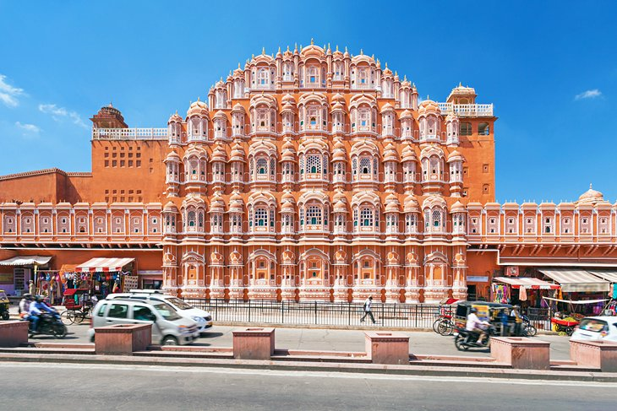

2. Amber Palace

3. City Palace
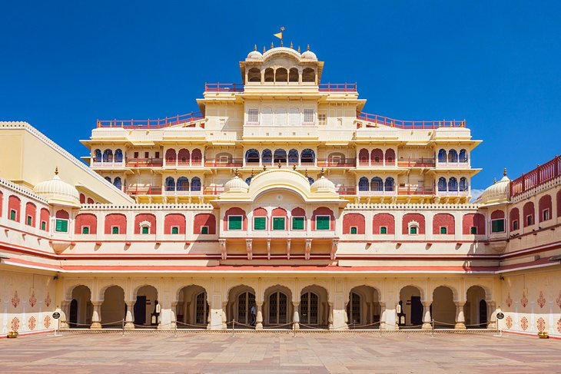

4. Jantar Mantar
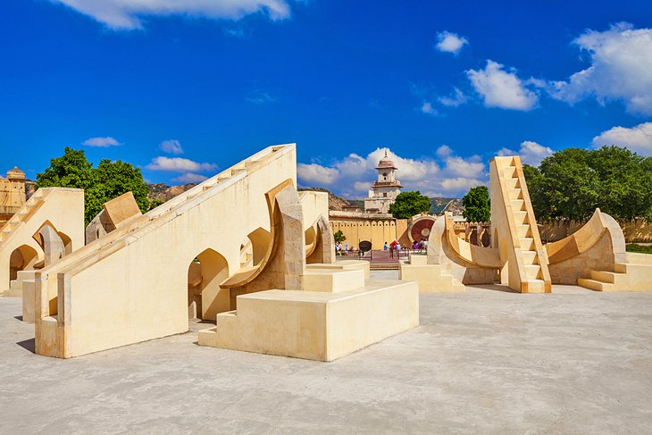

5. Jal Mahal


6. Nahargarh Fort


7. Albert Hall Museum
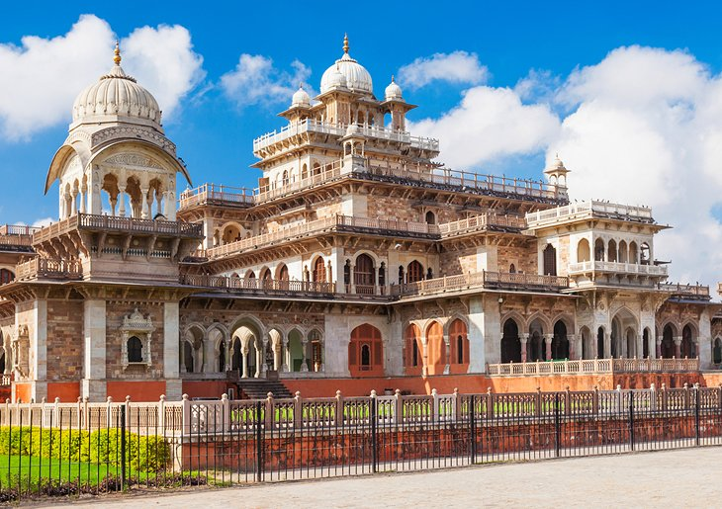

8. Birla Mandir


9. Galta Ji


10. Jaigarh Fort
